Packet Tracer - Implement VLANs and Trunking

|  |  |
| --- | --- |
| **NAME** | **MOHAMAD SAIFUL NIZAM BIN ABD AZIZ** |
| **NO. MATRIC** | **A179830** |
| **INSTRUCTOR** | **TS. DR. WAN FARIZA BINTI FAUZI** |

Packet Tracer - Implement VLANs and Trunking

# Topology

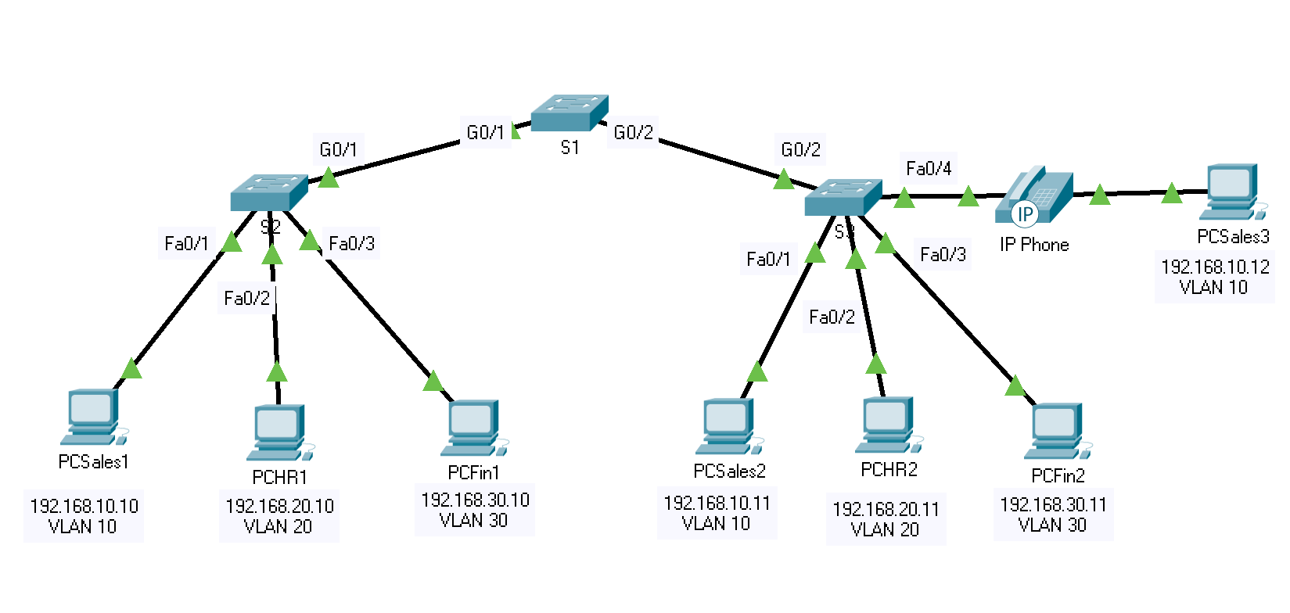

PC

Switch

# Addressing Table

| Device | Interface | IP Address | Subnet Mask | Switchport | VLAN |
| --- | --- | --- | --- | --- | --- |
| PCSales1 | NIC | 192.168.10.10 | 255.255.255.0 | S2 F0/1 | VLAN 10 |
| PCHR1 | NIC | 192.168.20.10 | 255.255.255.0 | S2 F0/2 | VLAN 20 |
| PCFin1 | NIC | 192.168.30.10 | 255.255.255.0 | S2 F0/3 | VLAN 30 |
| PCSales2 | NIC | 192.168.10.11 | 255.255.255.0 | S3 F0/1 | VLAN 10 |
| PCHR2 | NIC | 192.168.20.11 | 255.255.255.0 | S3 F0/2 | VLAN 20 |
| PCFin2 | NIC | 192.168.30.11 | 255.255.255.0 | S3 F0/3 | VLAN 30 |
| PCSales3 | NIC | 192.168.10.12 | 255.255.255.0 | S3 F0/4 | VLAN 10  VLAN 40 (Voice) |
| S1 | SVI | 192.168.99.252 | 255.255.255.0 | N/A | VLAN 99 |
| S2 | SVI | 192.168.99.253 | 255.255.255.0 | N/A | VLAN 99 |
| S3 | SVI | 192.168.99.254 | 255.255.255.0 | N/A | VLAN 99 |

Blank Line - no additional information

# Objectives

Part 1: Implement the Network Topology and Configure VLANs

Part 2: Assign Ports to VLANs

Part 3: Configure Static Trunking

Part 4: Configure Dynamic Trunking

# Background

You are working in a company that is getting ready to deploy a set of new 2960 switches in a branch office. You are working in the lab to test out the VLAN and trunking configurations that are planned. Implement the given network topology. Configure and test the VLANs and trunks.

# Instructions

## Implement the Network Topology and Configure VLANs

Set up the network as shown in the Topology using three 2960 switches, seven PCs and one IP Phone.

Connect the devices according to the port/interface labels shown in the Topology.

Power up the IP Phone by accessing the Physical Tab on the Device Dialog and attaching the power adapter. (Note: depending on you Packet Tracer version, you may not see the Device Dialog when you click on the IP Phone. To rectify this, you need to go to Options 🡪 Preferences, under the Show/Hide tab, uncheck the Hide Physical Tab)

Refer to the Addressing Table, rename the PCs and switches as well as configure the IP addresses and subnet masks for all PCs.

Configure VLANs on all three switches. Refer to the VLAN Table. Note that the VLAN names must match the values in the table exactly.

VLAN Table

| VLAN Number | VLAN Name |
| --- | --- |
| 10 | SALES |
| 20 | HR |
| 30 | FINANCE |
| 40 | Voice |
| 99 | Management |
| 100 | Native |

Blank Line - no additional information

## Assign Ports to VLANs

### Assign access ports to VLANs

On S2 and S3, assign ports to the VLANs. Refer to the Addressing Table.

### Configure the Voice VLAN port

Note the additional VLAN 40 (Voice) for the F0/4 interface on switch S3 in the Addressing Table. This is for voice VLAN functionality.

As shown in the topology, the S3 F0/4 interface connects to a Cisco IP Phone and PCSales3. The IP phone contains an integrated three-port 10/100 switch. One port on the phone is labeled Switch and connects to F0/4 on S3. Another port on the phone is labeled PC and connects to PCSales3. The IP phone also has an internal port that connects to the IP phone functions.

The S3 F0/4 interface must be configured to support user traffic to PCSales3 using VLAN 10 and voice traffic to the IP phone using VLAN 40 as shown below.

S3(config)# **interface f0/4**

S3(config-if)# **switchport voice vlan 40**

Additionally, the interface must also enable QoS and trust the Class of Service (CoS) values assigned by the IP phone. IP voice traffic requires a minimum amount of throughput to support acceptable voice communication quality. This command helps the switchport to provide this minimum amount of throughput.

S3(config-if)# **mls qos trust cos**

### Configure the virtual management interfaces

* + - 1. Create the virtual management interfaces (int vlan 99), on all three switches.
      2. Address the virtual management interfaces according to the Addressing Table.

### Connectivity test

* + - 1. Can S1 ping S2? Yes. Explain your answer.

No, because both switches haven’t configured the Static trunking and Dynamic Trunking yet.

* + - 1. Can S1 ping S3? Yes. Explain your answer.

No, because both switches haven’t configured the Static trunking and Dynamic Trunking yet.

* + - 1. Can S2 ping S3? Yes. Explain your answer.

No, because both switches haven’t configured the Static trunking and Dynamic Trunking yet.

* + - 1. Can PCSales2 ping PCSales1? Yes. Explain your answer.

No, because both of the PC’s are linked by by different switches that are not trunked, therefore the switches must be trunked for PC’s to communicate across the switches in the same VLAN.

* + - 1. Can PCSales2 ping PCSales3? Yes. Explain your answer.

Yes, because both of the PC’s are under the same switch, therefore trunking isn’t require for both of the PC’s to communicate each other in the same VLAN.

## Configure Static Trunking

* + - 1. Configure the link between S1 and S2 as a static trunk. Disable dynamic trunking on this port.
      2. Disable DTP on the switch port on both ends of the trunk link.

Record the command used switchport nonegotiate

* + - 1. Configure the trunk with the native VLAN and eliminate native VLAN conflicts if any.

## Configure Dynamic Trunking

* + - 1. Assume that the trunk port on S3 is set to the default DTP mode for 2960 switches. Configure G0/2 on S1 so that it successfully negotiates trunking with S3.
      2. Configure the trunk with the native VLAN and eliminate native VLAN conflicts if any.

Record the command used switchport trunk native vlan 100

Did you encounter any native VLAN conflicts? no

If yes, how did you resolve it? -

## Connectivity Test

* + - 1. Repeat the ping tests carried out in Part 2: Step 4.
      2. Record your ping test results.

S1 -> S2

S1 -> S3

S2 -> S3

PC2 -> PC1

PC2 -> PC3

* + - 1. Compare the ping test results with the earlier ping test results.

All the ping test results are successful compared to the earlier ping test results.

* + - 1. At this point, all the ping tests should be successful. Troubleshoot if necessary.

## Reflection

* + - 1. What benefits can VLANs provide to the network?

VLANs have a number of advantages, including simplicity of management, broadcast domain limitation, reduced broadcast traffic, and security policy enforcement.

* + - 1. Why is it important to configure the links between the switches as trunk links?

The trunking major purpose is to carry traffic across switches while also maintaining VLAN information. The trunk link, unlike an access link, is not limited to a single VLAN and can transmit traffic from many VLANs through a point-to-point link between two devices that support the protocol. Because a trunk is often a point-to-point connection between two switches, running it in full-duplex mode is very efficient and highly recommended.

* + - 1. List some show commands to verify your VLAN and trunking configurations.
* show running-config
* show interfaces trunk
* show interfaces switchport
* show vlan
* show dtp interface
* show mac-address-table